PD_TC_01 – OrangeHRM _ Personal Details _ Update the Personal Details

Launch the URL

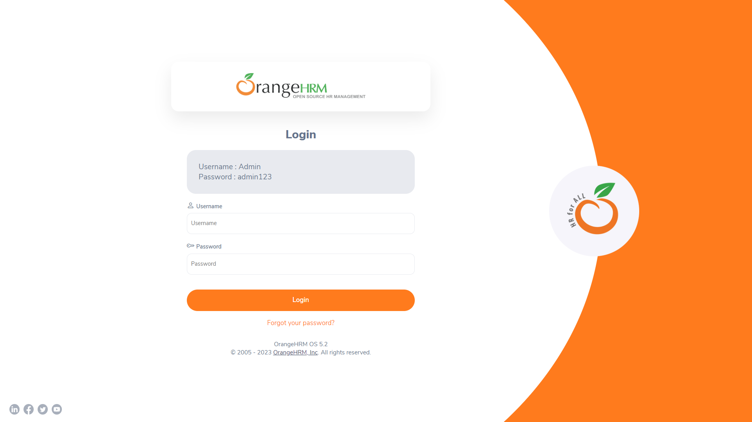

Login to the application with Valid credentials

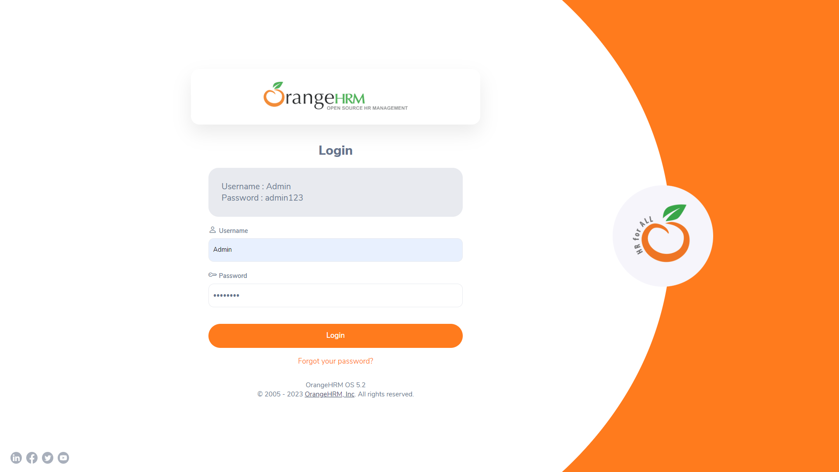

Logged successfully & navigated to personal details tab

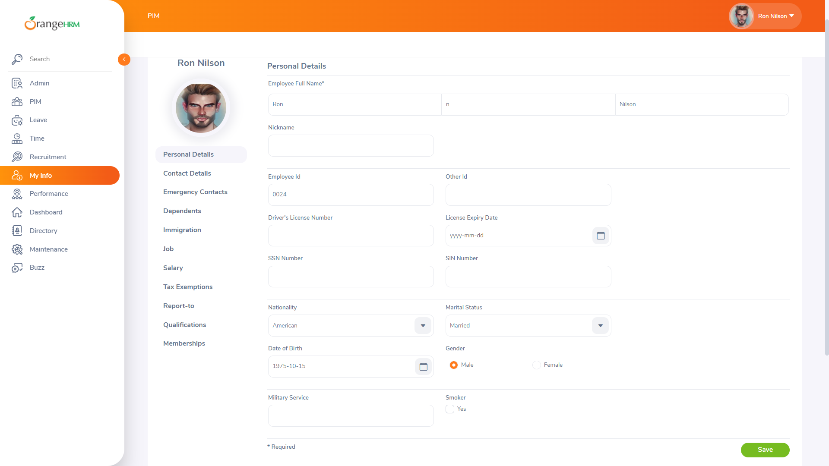

Before Updating the Personal Details



Personal Details Should be Updated

